Features that should get updated

DATASET:

Dataset od a players

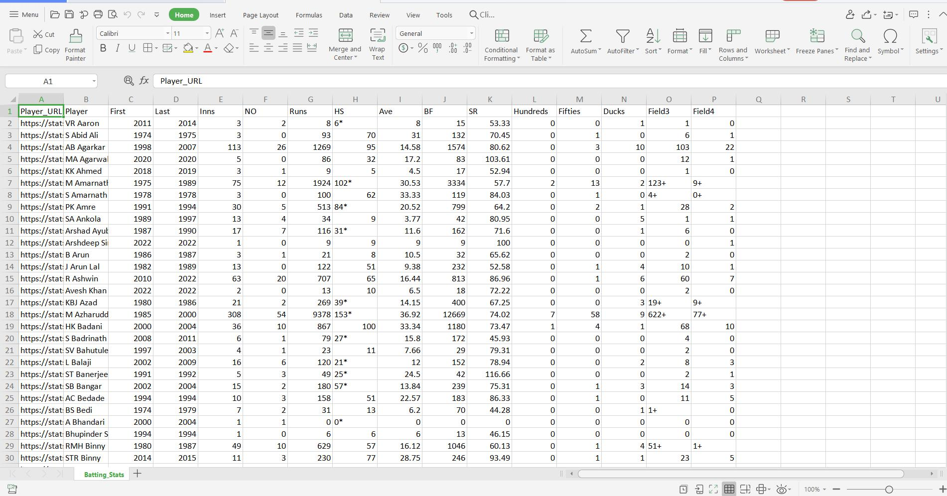

Dataset of a Batsman:

